Revival Centre Gift Scheme Order Form

*Your gift is a donation for the work of the Revival Centre Matugga supported by the UK charity Give A Child A Hope UK Charity No 1153184*

The Gift Scheme allows you to combine support with buying a present for someone for Christmas or on other occasions. The scheme can be used all year round but if you are ordering for Christmas, we need to receive your order at least 10 working days before Christmas, so that we can dispatch intime for Christmas post.

**Customer Details**

Title: _____ First Name ____________________ Surname: ______________________

Address: ________________________________________________________________

_______________________________________ Post Code ______________________

Tel: _________________________ Email: _________________________________

Please donate any amount you like from £5 to £105 for each.

|  |  |
| --- | --- |
|  | And the value of the gift for each card |
| Gift Card 1 |  |
| Gift Card 2 |  |
| Gift Card 3 |  |
| Gift Card 4 |  |
| Gift Card 5 |  |

Total Cost £________

You will receive in the first class post a beautifully printed gift card(s). The actual amount that you have given will not be shown. *(You may wish to add this in your personal note).* The facing page of the card will be blank for you to add your own personal message to the recipient.

**Please send this** **completed form** **by post to**: For Attention of ‘Give A Child A Hope, GACAH c/o St John’s Church Office, Bolling Road, Ben Rhydding, West Yorkshire, LS29 8PN’

Payment options if you **are eligible** for Gift-Aid – make a cheque payable to ‘The Partnership Trust’ and include the cheque with the form, along with the Gift Aid Declaration below.

Payment options if **not eligible** for Gift-Aid Aid – make a cheque payable to ‘Give A Child A Hope’ and include the cheque with this form.

Alternatively you can pay online by using the CAF online giving page on our web site with link: <https://cafdonate.cafonline.org/18996>

For more information please contact Carole by email at [giveachildahope@gmail.com](mailto:giveachildahope@gmail.com)

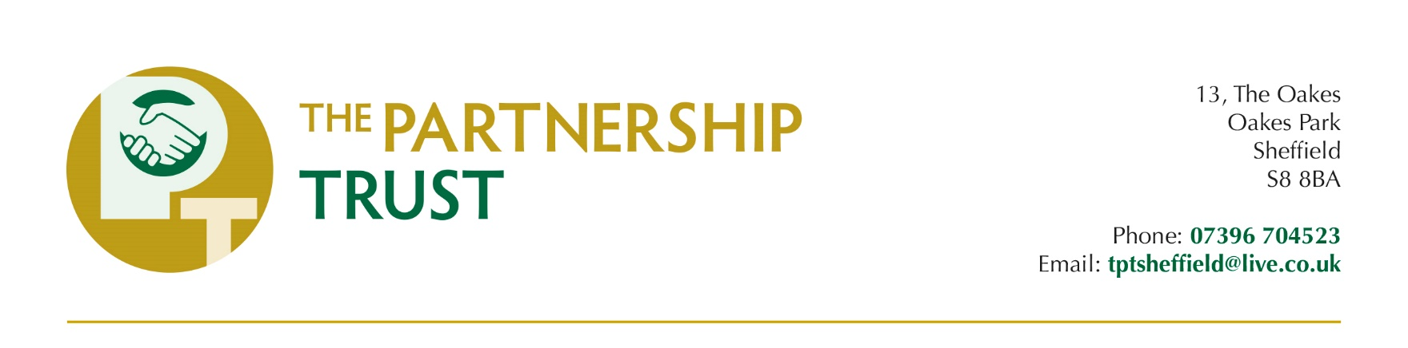

**Donor Application Form: Individual**

|  |  |
| --- | --- |
| **Name** |  |
| **Address and Postcode** |  |
| **Country of Residence** |  |
| **Email address** |  |
| **Telephone number (optional)** |  |
| **Which Partner do you wish your donations to support?** |  |
| **Amount of donation** | £ |
| **Frequency of donation**  **(Tick one only)** | Image result for Check Off BoxesImage result for Check Off Boxes  One-off Monthly  Image result for Check Off Boxes  Other - please specify: |
| **Signed** |  |
| **Date** |  |

**If you are a UK tax payer and wish The Partnership Trust to claim Gift Aid on your donation(s), please complete page 2.**

**For new donors, once your application has been processed, you will receive confirmation that your Donor Account has been created. You will also receive the Partner Code to use when you make payments online or by standing order.**

**Gift Aid Declaration**

**Boost your donation by 25p of Gift Aid for every £1 you donate**

Gift aid is reclaimed by the charity from the tax you pay for the current tax year. Your address is needed to identify you as a current UK taxpayer.

**In order to gift aid your donation you must tick one of the boxes below:**

**I want to Gift Aid**:

the enclosed donation of £ __________________ only

all donations I make from the date of this declaration until I notify you otherwise

all donations I have made in the last 4 tax years and all donations I make from the date of this declaration until I notify you otherwise

I am a UK taxpayer and understand that if I pay less Income Tax and/or Capital Gains Tax than the amount of Gift Aid claimed on all my donations in that tax year it is my responsibility to pay any difference.

|  |  |
| --- | --- |
| Name (printed): |  |
| Signed: |  |
| Date: |  |

If this declaration covers donations you intend to make in the future, please notify The Partnership Trust if you:

* want to cancel this declaration
* change your name or home address
* no longer pay sufficient tax on your income and/or capital gains

If you pay Income Tax at the higher or additional rate and want to receive the additional tax relief due to you, you must include all your Gift Aid donations on your Self-Assessment tax return or ask HM Revenue and Customs to adjust your tax code.

**PLEASE NOTE**

Under Gift Aid regulations, close relatives of a Partner (or of their spouse) must **not** make a Gift Aid declaration on any gift to them unless the gift is for ministry purposes **only** (i.e. the costs of equipment, training, materials, travel for ministry purposes and other facilities relating directly to their ministry/work which they incur and aren’t reimbursed to them).

In this case the Donor must write a letter to the Partner, and send a copy of that letter to The Partnership Trust, stipulating that the donations are for ministry purposes **only** and not be used for personal support (eg daily living expenses).